Design of TRLB outside SM
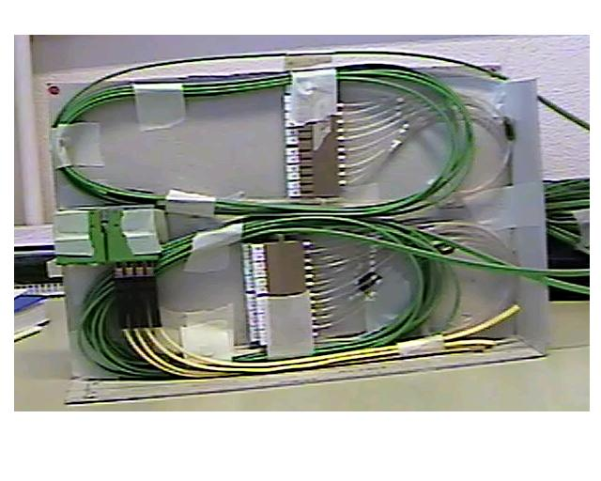
170

240

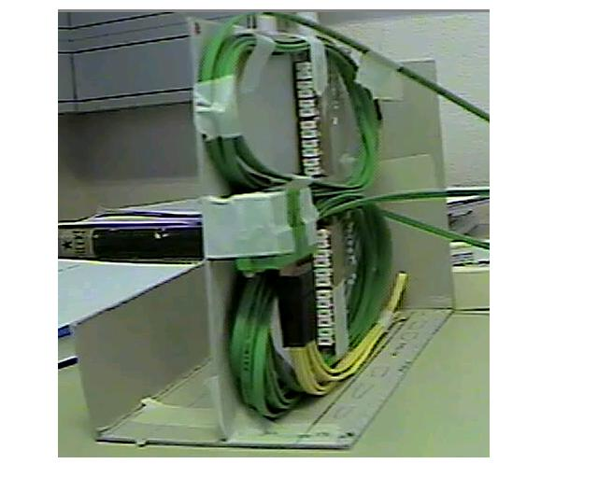

100

→ 2x4 fanouts of 3m long + MFS adaptor : OK

- Available place to be fixed (size of the box) →prototype ?
- Fixation
- Multi-ribbon fixation
- Steps for assembling to be defined
- Access for dismounting – cleaning…
- …

